**How to Support Your Volunteers: The Principle of Give to Gain**

Remember that thousands of people up and down our wonderful nation give up their free time to coach, make teas and coffees, manage teams, chair committees and to do all the other jobs required in a busy club. And why? So that others have the chance to develop in the sport of Athletics.

This Volunteers Week we want to celebrate all the amazing work our Volunteers but also help raise awareness about how Clubs and Groups can create positive volunteering environments that people want to part of.

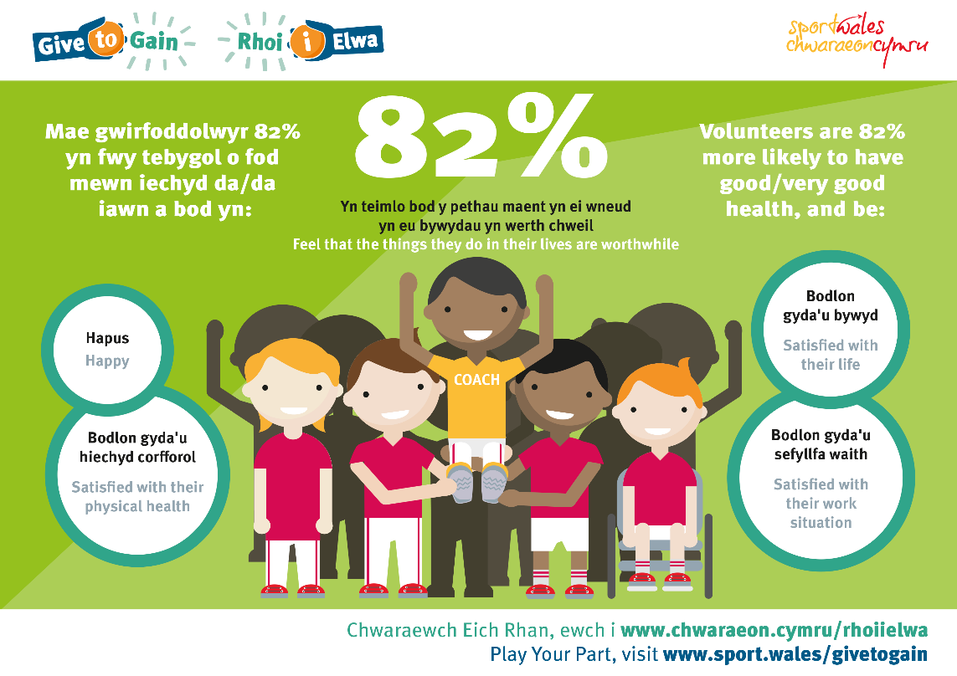

***What do we need to give our prospective Volunteers to gain their trust, time and energy?***

Sport Wales, together with the sports sector in Wales, has developed a set of principles setting out what we all want to achieve with sports volunteering in Wales. They are what we call our [Give to Gain](https://www.youtube.com/watch?v=KXlHVYpotbY) principles:

* Volunteers know exactly what is expected of them
* Volunteers are valued, developed and supported
* 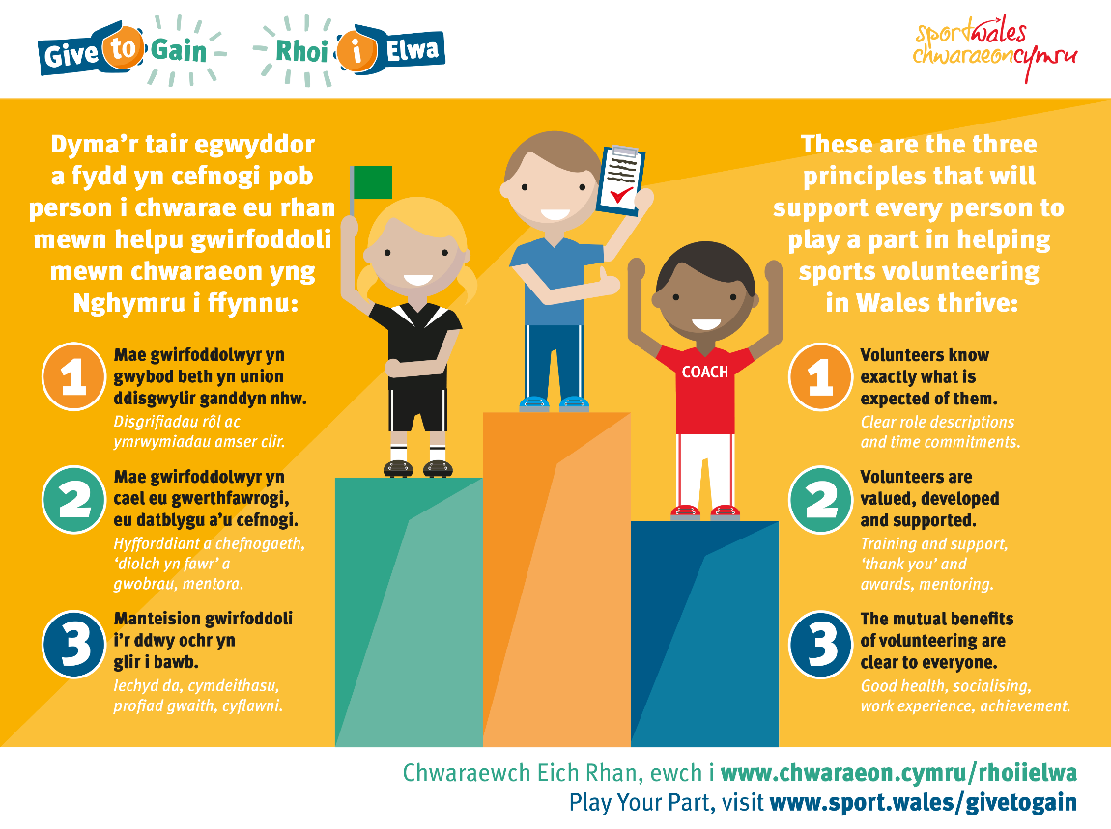The mutual benefits of volunteering are clear to everyone

Both actions and words, can make the difference. Saying a simple ‘thank you’ to show someone they’re valued, or the ‘are you ok?’ chat with the volunteer who seems to do everything can be the validation they need to feel that part of a team that cares about them.

***What could you do differently?***

Why not have a look at how some of other sports clubs have gone about creating a positive volunteer environment that the community they service wants to be a part of!

[Newport Cricket Club](https://www.youtube.com/watch?v=fBEqeK86Y2U&feature=youtu.be)

[Valleys’ Gymnastics Academy](https://youtu.be/x8wj0oB3kh4)

For more support around recruitment and retention of Volunteers here is are the link to;

* Volunteer Resource Pack for Clubs - document to assist the club to develop the processes and practices needed to create positive volunteering environment
* Club Welcome Pack Template for New Volunteers – for Clubs to brand and use as part of their volunteer induction process

Further role descriptions documents and associated training videos can be found on the [Clubs Portal](https://welshathletics.clubserve.net/) platform.